**129. Styling Active Router Links**

* -: We of course added navigation to our page.
* But one issue is that whilst the does work fine we get no visual indication of what the currently active route is.

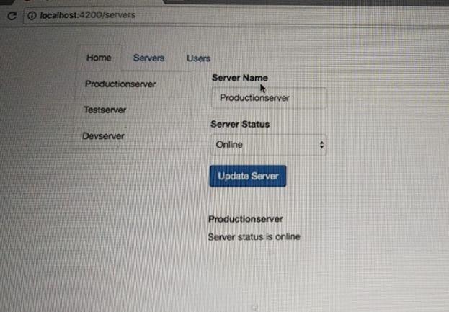

* It would be nice if the selected tab would change and that of course is only a CSS thing, because if you check your app component here you'll see we got this active class on the list item which determines whether this is marked as active, if that's if this link gets the right CSS classes or not.
* So it would be nice if we could dynamically set this class.
* I will remove it from here and how, how can we now set it dynamically? Angular gives us a specific directive for this.
* **The Router Link Active Directive:**
* And the convenient thing about this directive, is you can add it to a wrapping element like we do here to the list item, or also of course, to the link itself, and it will attach the class you specify in between here, for example, active.

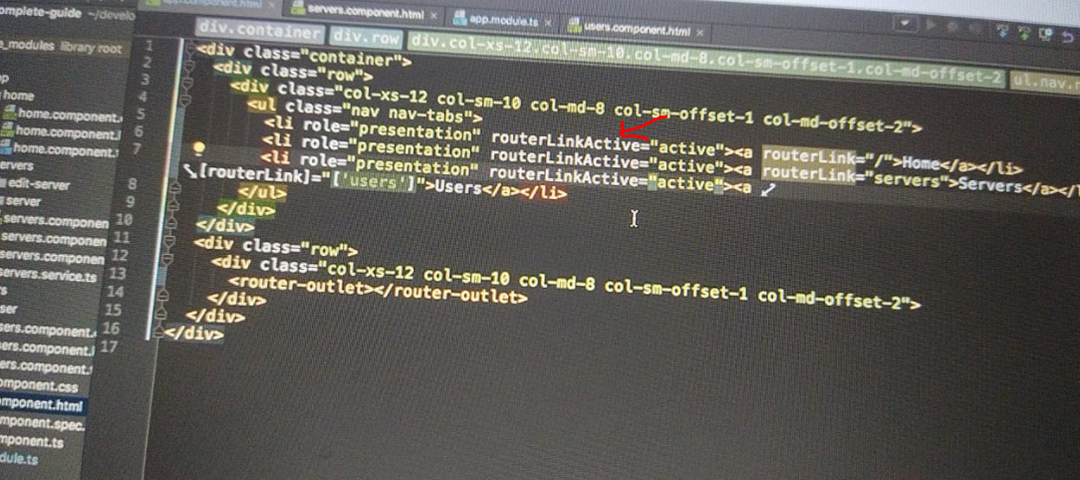

* So this should be a string, to that element it sits on.
* Now active on the link itself wouldn't do anything when using Bootstrap.
* Here for this tabs look, we need to add it to the list item but this of course depends on which package or which CSS code you are using.
* And here you could specify any class you want like my active class or whatever that is.
* So here it is active to make it look nice in Bootstraps world, and I will add it to all my links here.
* So now theoretically all my links should receive this active CSS class once they are clicked or when they are active.
* So if we have a look at this, it seems to work because we still have homes set as our active page even though we remove this class, this active class we had there before if I click servers it gets marked as active too and the same for users.

* So this works.
* But somehow home is always marked as active.
* So that does not seem to work correctly.
* What's wrong here? *Well, the router link active directive does one thing.*
* *It analyzes your currently loaded path, and then checks which links lead to a route which uses this path.*
* *And by default it marks an element as active.*
* *It adds this CSS class, if it contains the path you are on, or if this link is part of the path, which is currently loaded.*
* *So for the slash service link or the slash users link, this of course the case once we click servers or users.*
* *For the slash nothing link, which is the first one, the homepage.*
* This is always the case.
* We always have slash nothing at the beginning of our path here.
* So if we are on slash users, well there is this empty path in between you could say, the same for servers and the same for just home of course.
* ***So the empty path segment is part of all paths.***
* Still we don't want to have home being marked as active all the time.
* So to fix this we can add some configuration to this Router Link Active Directive.
* And I will just split this up all over multiple lines to make this a bit easier to read.
* **Router Link Active options**
* So we can add a special configuration to our Router Link Active Directive.
* So on the same element as Router Link Active was added to we can add router link active options.
* And this now needs some property binding because we don't just pass a string there.
* Instead we pass a JavaScript object and that would not work without having our square brackets.

* So with square brackets we can pass anything which will be resolved dynamically like this JavaScript object.
* And here we can basically add one important configuration say exact, and set this to True.
* ***So Exact is a kind of a reserved property.***
* On this object you pass to Router Link Active options and this will now basically tell Angular, only at this Router Link Active class.
* So does active CSS class in this case.
* If the exact the full path, is well whatever this link leads to.
* So only if everything is just slash and not if it is only part of the path.
* So if this in place, now you see it still is marked as active on the empty path at the starting page.

* But if you go to slash servers, now only servers is marked as active because now we fixed this, we changed the default behavior to make sure we only mark this, if the full path is well, whatever we have on our router link.